***Risk management plan***

*Prepared by: Hazem Hamada Abdellatif Mohamed, 16p3100.*

***Introduction:***

This plan documents the processes, tools and procedures that will be used to manage and control those events that could have a negative impact on the system. It’s the controlling document for managing and controlling all project risks.

***Methodology:***

A risk is any event that could prevent the project from progressing as planned, or from successful completion. Risks can be identified from a number of different sources. Some may be quite obvious and will be identified prior to project kick off.

Others will be identified during the project lifecycle, and a risk can be identified by anyone associated with the project. Some risk will be inherent to the project itself, while others will be the result of external influences that are completely outside the control of the project team.

The Project Manager has overall responsibility for managing project risk. Project team members may be assigned specific areas of responsibility for reporting to the project manager.

Throughout all phases of the project, a specific topic of discussion will be risk identification. The intent is to instruct the project team in the need for risk awareness, identification, documentation and communication.

Risk awareness requires that every project team member be aware of what constitutes a risk to the project, and being sensitive to specific events or factors that could potentially impact the project in a positive or negative way.

Risk identification consists of determining which risks are likely to affect the project and documenting the characteristics of each.

Risk communication involves bringing risk factors or events to the attention of the project manager and project team.

The project manager will identify and document known risk factors during creation of the Risk Register.

It is the project manager’s responsibility to assist the project team and other stakeholders with risk identification, and to document the known and potential risks in the Risk Register. Updates to the risk register will occur as risk factors change. Risk management will be a topic of discussion during the regularly scheduled project meetings.

The project team will discuss any new risk factors or events, and these will be reviewed with the project manager.

The project manager will determine if any of the newly identified risk factors or events warrant further evaluation. Those that do will undergo risk quantification and risk response development, as appropriate, and the action item will be closed. At any time during the project, any risk factors or events should be brought to the attention of project manager using Email or some other form of written communication to document the item. The project manager is responsible for logging the risk to the Risk Register. Notification of a new risk should include the following Risk Register elements:

• Description of the risk factor or event, e.g. conflicting project or operational initiatives that place demands on project resources, unexpected study outcomes, delays, etc.

• Probability that the event will occur. For example, a 50% chance that the vendor will not have an animal colony that meets the criteria available.

• Schedule Impact. The number of hours, days, week, or months that a risk factor could impact the schedule. As an example, the animals require an additional 3 months to meet age requirements.

• Scope Impact. The impact the risk will have on the envisioned accomplishments of the project. Delayed animal delivery may result in a reduction in the number of studies that can be completed within the contract period of performance.

• Quality Impact. A risk event may result in a reduction in the quality of work or products that are developed. As an example, lack of funding caused by cost overruns may result in the reduction of the study size and impact statistical empowerment

• Cost Impact. The impact the risk event, if it occurs is likely to have on the project budget.

***Roles and responsibilities:***

The responsibility for managing risk is shared amongst all the stakeholders of the project. However, decision authority for selecting whether to proceed with mitigation strategies and implement contingency actions, especially those that have an associated cost or resource requirement rest with the Project Manager who is responsible for informing the funding agency to determine the requirement for a contract modification. The following tables details specific responsibilities for the different aspects of risk management.

Risk Identification: All project stakeholders

Risk Registry: Project Manager

Risk Assessment: All project stakeholders

Risk Response Options Identification: All project stakeholders

Risk Response Approval: PM with concurrence from CO/PO/COTR

Risk Contingency Planning; Project Manager(s)

Risk Response Management; Project Managers

Risk Reporting; Project Manager

***Risk categories:***

There are four main risk categories considered in this project.

1. **Critical:** A non-compliance finding resulting in process, or operational degradation, A security finding requiring immediate corrective action prior to continued operation ,Reoccurring violation of any safety regulation resulting in serious injury, Production errors containing regulatory violations that pose direct consequence to the operation. In addition the cost of this category is usually very high as it has high impact on the project, and must be handled carefully, and must be toked into consideration.
2. **Moderate:** Security finding requiring a Corrective Action Plan, Production element errors that may pose indirect consequences to the operation. This category of risks that has a moderate impact and cost on the project but if it happens frequently it could be dangerous and negatively affect the project, so it have to be handled but not as important as the critical risks.
3. **Minor:** No regulatory action anticipated, No compliance impact anticipated, No evident security threat affected, Minor errors in completed Company policy & procedures, Production errors containing quality system and / or opportunities for improvement. This category of risks is not so important to be handled unless it happens so frequently bus it will cost much, so it is better not to be handled as it has very low impact and cost on the project.
4. **Negligible:** No regulatory/compliance violation, No security/confidentiality element affected, On time production, Properly executed communications. This category of risks is negligible, so it is not even handled as if it happens it doesn’t affect the project at all.

***Impacts:***

For each of the impact categories the impact assessment should include consideration of the following areas of impact also:

• Cost – This impact is usually estimated as a dollar amount that has a direct impact to the project. However, cost is sometimes estimated and reported as simply additional resources, equipment, etc. This is true whenever these additional resources will not result in a direct financial impact to the project due to the fact the resources are loaned or volunteer, the equipment is currently idle and there is no cost of use, or there are other types of donations that won’t impact the project budget. Regardless of whether there is a direct cost, the additional resources should be documented in the risk statement as part of the mitigation cost.

• Scope – Whenever there is the potential that the final product will not be completed as originally envisioned there is a scope impact. Scope impact could be measured as a reduction of the number of studies completed, or not providing a deliverable such as an IND.

• Schedule – It is very important to estimate the schedule impact of a risk event as this often results is the basis for elevating the other impact categories. Schedule delays frequently result in cost increases and may result in a reduction of scope or quality. Schedule delays may or may not impact the critical path of the project and an associated push out of the final end date.

• Performance/Quality – Performance/Quality is frequently overlooked as an impact category and too often a reduction in quality is the preferred choice for mitigation of a risk. “Short cuts” and “low cost replacements” are ways of reducing cost impacts. If not documented appropriately and approved by the project sponsor, mitigation strategies that rely upon a reduction in quality can result in significant disappointment by the stakeholders. Most risks will be assigned one category, but some might be assigned more than one, or all.

***Risk probability and impact:***

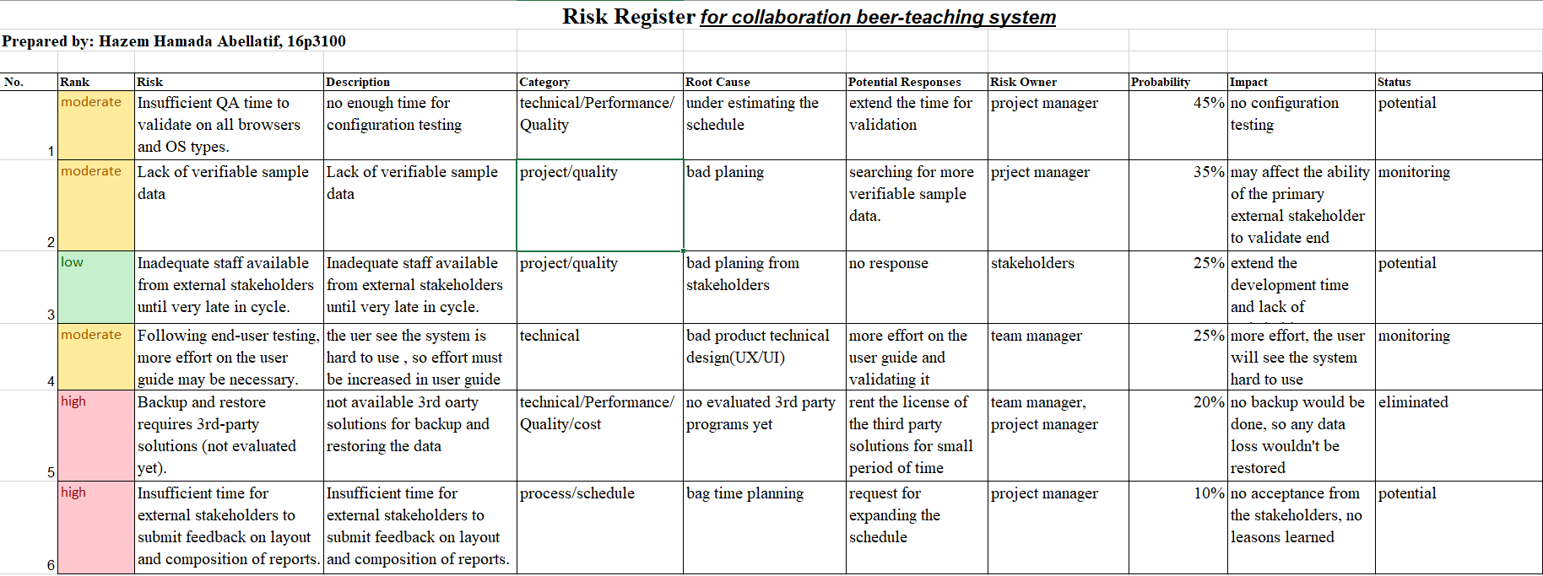

***Risk response:***

For each identified risk, a response must be identified. It is the responsibility of the project team to select a risk response for each risk. The project team will need the best possible assessment of the risk and description of the response options in order to select the right response for each risk. The probability of the risk event occurring and the impacts will be the basis for determining the degree to which the actions to mitigate the risk should be taken. One way of evaluating mitigation strategies is to multiply the risk cost times the probability of occurrence. Mitigation strategies that cost less than risk probability calculation should be given serious consideration. The possible response options are:

• Avoidance – Change the project to avoid the risk. Change scope, objectives, etc.

• Transference – Shift the impact of a risk to a third party (like a subcontractor). It does not eliminate it, it simply shifts responsibility.

• Mitigation – Take steps to reduce the probability and/or impact of a risk. Taking early action, close monitoring, more testing, etc.

• Acceptance – Simply accept that this is a risk. When choosing acceptance as a response the IMPD is stating that given the probability of occurring and the associated impact to the project that results, they are not going to take any actions and will accept the cost, schedule, scope, and quality impacts if the risk event occurs.

• Deferred – A determination of how to address this risk will be addressed at a later time. The results of the risk assessment process are documented in each Risk Statement and summarized in the Risk Register which will be reported on a monthly basis.

***Risk Contingency Planning:***

Contingency planning is the act of preparing a plan, or a series of activities, should an adverse risk occur. Having a contingency plan in place forces the project team to think in advance as to a course of action if a risk event takes place.

• Identify the contingency plan tasks (or steps) that can be performed to implement the mitigation strategy.

• Identify the necessary resources such as money, equipment and labour.

• Develop a contingency plan schedule. Since the date the plan will be implemented is unknown, this schedule will be in the format of day 1, day 2, day 3, etc., rather than containing specific start and end dates.

• Define emergency notification and escalation procedures, if appropriate.

• Develop contingency plan training materials, if appropriate.

• Review and update contingency plans if necessary.

• Publish the plan(s) and distribute the plan(s) to management and those directly involved in executing the plan(s).

Contingency may also be reflected in the project budget, as a line item to cover unexpected expenses. The amount to budget for contingency may be limited to just the high probability risks. This is normally determined by estimating the cost if a risk occurs, and multiplying it by the probability. ***For example***, assume a risk is estimated to result in an additional cost of $50,000, and the probability of occurring is 80%. The amount that should be included in the budget for this one item is $40,000.

Associated with a contingency plan, are start triggers and stop triggers. A start trigger is an event that would activate the contingency plan, while a stop trigger is the criteria to resume normal operations. Both should be identified in the Risk Register and can be embedded, example; the stop trigger can be included in the contingency plan field.

***Tracking and response:***

As project activities are conducted and completed, risk factors and events will be monitored to determine if in fact trigger events have occurred that would indicate the risk is now a reality.

Based on trigger events that have been documented during the risk analysis and mitigation processes, the project team or project managers will have the authority to enact contingency plans as deemed appropriate. Day to day risk mitigation activities will be enacted and directed by the project managers.

Contingency plans that once approved and initiated will be added to the project work plan and be tracked and reported along with all of the other project activities.

Risk management is an ongoing activity that will continue throughout the life of the project. This process includes continued activities of risk identification, risk assessment, planning for newly identified risks, monitoring trigger conditions and contingency plans, and risk reporting on a regular basis. Project status reporting contains a section on risk management, where new risks are presented along with any status changes of existing risks. Some risk attributes, such as probability and impact, could change during the life of a project and this should be reported as well.